ASSIGNMENT GROUP WORK
Qualification | Pearson BTEC Level 5 Higher National Diploma in Computing
Unit number and title | Unit 22: Application Development
Submission date | 26/06/2026 | Date Received 1st submission
Re-submission Date |  | Date Received 2nd submission
Group number: 1 | Student names & codes | Final scores | Signatures
 | SIN VAN HUYNH & BH02116 |  | HUYNH
 | LE TIEN DAT & BH01724 |  | DAT
 | PHAM QUANG MINH QUAN |  | QUAN
 | NGUYEN THANH TRUNG & BH02323 |  | TRUNG
 | NGUYEN VAN QUANG & BH02289 |  | QUANG
Class | SE08101 | Assessor name | NGUYEN THANH TRIEU
Plagiarism
Plagiarism is a particular form of cheating. Plagiarism must be avoided at all costs and students who break the rules, however innocently, may be penalised. It is your responsibility to ensure that you understand correct referencing practices. As a university level student, you are expected to use appropriate references throughout and keep carefully detailed notes of all your sources of materials for material you have used in your work, including any material downloaded from the Internet. Please consult the relevant unit lecturer or your course tutor if you need any further advice.
Student Declaration
I certify that the assignment submission is entirely my own work and I fully understand the consequences of plagiarism. I declare that the work submitted for assessment has been carried out without assistance other than that which is acceptable according to the rules of the specification. I certify I have clearly referenced any sources and any artificial intelligence (AI) tools used in the work. I understand that making a false declaration is a form of malpractice.
P1 | P2 | P3 | P4 | P5 | P6 | M1 | M2 | M3 | M4 | M5 | D1 | D2

OBSERVATION RECORD
 | Student
 | Description of activity undertaken
 | Assessment & grading criteria
 | How the activity meets the requirements of the criteria
 | Student signature: |  |  | Date:
 | Assessor signature: |  |  | Date:
 | Assessor name:
❒ Summative Feedback:  Resubmission Feedback:

Grade: |  |  | Assessor Signature: |  |  | Date:
Internal Verifier’s Comments:
Signature & Date:

Table of Contents
I. Introduction 7
II. Content 7
Activity 1 (P1 + P2) 7
Activity 2 (P3 + M2) 8
P3. Have research on software development tools and techniques would be suitable to implement the solution 8
1. Software Development Methodologies (SDLC Models) 8
2 Software Development Tools 12
M2. Justifying development tools and development methodology selected 16
1. Justification for Selecting the Agile SDLC Model 16
2. Justification for Selecting Microsoft Project 17
3. Justification for Selecting Android Studio 17
4. Justification for Selecting Git & GitHub 18
Activity 3 (M1) 19
M1. Analyse a business- related problem using appropriate methods to produce a well-structured software design document 19
1. What is OOAD? 19
2. What is UML? 19
3. Use Case Diagram 21
4. Class diagrams 24
5. Individual Discussion 27
Activity 4 (D1) 30
D1. Evaluate the solution to a business-related problem and the preferred software development methodology by comparing the various software development tools and techniques researched 30
Assignment 2 33
Activity 1 (P4 + M3) 33
Activity 3 (P6 + M5 +D2) 43
References 45

Figure 1: Waterfall Model 9
Figure 2: Agile Model 10
Figure 3: Spiral Model 11
Figure 4: Microsoft Project 12
Figure 5: Jira 13
Figure 6: Android Studio 14
Figure 7: Android Studio code 14
Figure 8: Git & GitHub 15
Figure 9: What is OOAD? 19
Figure 10: What is UML? 20
Figure 11: Use Case Diagram 21
Figure 12: Class diagrams 24

I. Introduction
The rapid development of Artificial Intelligence (AI) has significantly transformed the education sector by providing students with faster and more personalized learning experiences. Traditional learning methods often require students to search through multiple websites, books, or educational platforms to find answers to their academic questions. This process can be time-consuming and may reduce learning efficiency. To address these challenges, BrightPath Learning proposes the development of an AI-powered mobile application called AI Study Mentor, designed specifically for middle school, high school, and university students.
The AI Study Mentor application enables students to submit academic questions in both text and image formats and receive instant, intelligent responses generated by Artificial Intelligence. In addition to answering questions, the application provides step-by-step explanations, personalized learning support, practice quizzes, progress tracking, and gamification features to encourage continuous learning. By integrating AI technology into a single mobile platform, the application aims to create an efficient, convenient, and engaging learning environment for students.
This report presents the software design and development plan for the AI Study Mentor application. It begins by analysing the business problem, identifying both user and system requirements, and evaluating potential project risks. The report also researches suitable software development methodologies and development tools before justifying the selected approach. Furthermore, Object-Oriented Analysis and Design (OOAD) techniques and UML diagrams are used to model the system architecture, while testing strategies are proposed to ensure software quality. Finally, the report evaluates the chosen solution by comparing it with alternative methodologies and development tools to demonstrate its suitability for the project.
Overall, this document aims to provide a comprehensive software design proposal that satisfies the requirements of BrightPath Learning while ensuring that the AI Study Mentor application is maintainable, scalable, secure, and capable of delivering an effective AI-assisted learning experience for students.

II. Content

Activity 1 (P1 + P2)
Activity 1 was presented separately in the group presentation and focused on analysing the business problem and identifying the requirements for the AI Study Mentor mobile application. The presentation included a well-defined problem statement, stakeholder analysis, user and system requirements, potential challenges faced by BrightPath Learning, possible business application solutions, and an assessment of project risks together with appropriate mitigation strategies.
The findings from Activity 1 provide the foundation for the remaining sections of this report. Based on the identified requirements and risk analysis, the following sections will discuss suitable software development methodologies and tools, propose the system design using OOAD and UML techniques, and evaluate the selected solution for the AI Study Mentor project.

Activity 2 (P3 + M2)

P3. Have research on software development tools and techniques would be suitable to implement the solution
Choosing an appropriate software development methodology and suitable development tools is essential for delivering a high-quality software application. Different SDLC models provide different approaches to managing project activities, while development tools improve productivity, collaboration, testing, and deployment. This section researches several software development methodologies and software tools that could be applied to the AI Study Mentor mobile application.

1. Software Development Methodologies (SDLC Models)
What is SDLC?
The software development lifecycle (SDLC) is the cost-effective and time-efficient process that development teams use to design and build high-quality software. The goal of SDLC is to minimize project risks through forward planning so that software meets customer expectations during production and beyond. This methodology outlines a series of steps that divide the software development process into tasks you can assign, complete, and measure. (amazon, 2026)
3 in the popular development model
- Waterfall
- Agile
- Spiral
1.1 Waterfall Model
Definition
- The waterfall model arranges all the phases sequentially so that each new phase depends on the outcome of the previous phase. Conceptually, the design flows from one phase down to the next, like that of a waterfall.
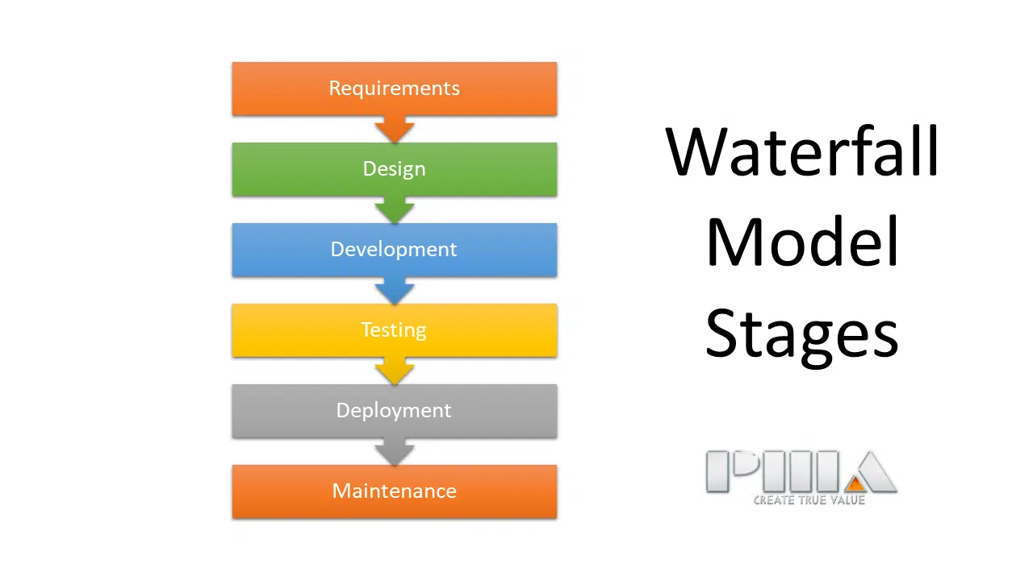
Figure 1: Waterfall Model
Advantages
Advantages | Explanation
Simple structure | Easy for beginners to understand and manage because each phase has a clearly defined objective.
Well-documented | Every stage produces documentation that supports maintenance and knowledge transfer.
Easy project tracking | Project progress can be measured because each phase has clear deliverables.
Suitable for stable projects | Works well when requirements are fixed and unlikely to change.

Disadvantages
Disadvantages | Explanation
Difficult to change requirements | Changes after the design phase require significant rework.
Testing occurs late | Defects are often discovered only after implementation.
High maintenance cost | Requirement changes increase project cost considerably.
Limited customer feedback | Users normally evaluate the system only near project completion.

1.2 Agile Model
Definition
- The agile model arranges the SDLC phases into several development cycles. The team iterates through the phases rapidly, delivering only small, incremental software changes in each cycle. They continuously evaluate requirements, plans, and results so that they can respond quickly to change. The agile model is both iterative and incremental, making it more efficient than other process models.
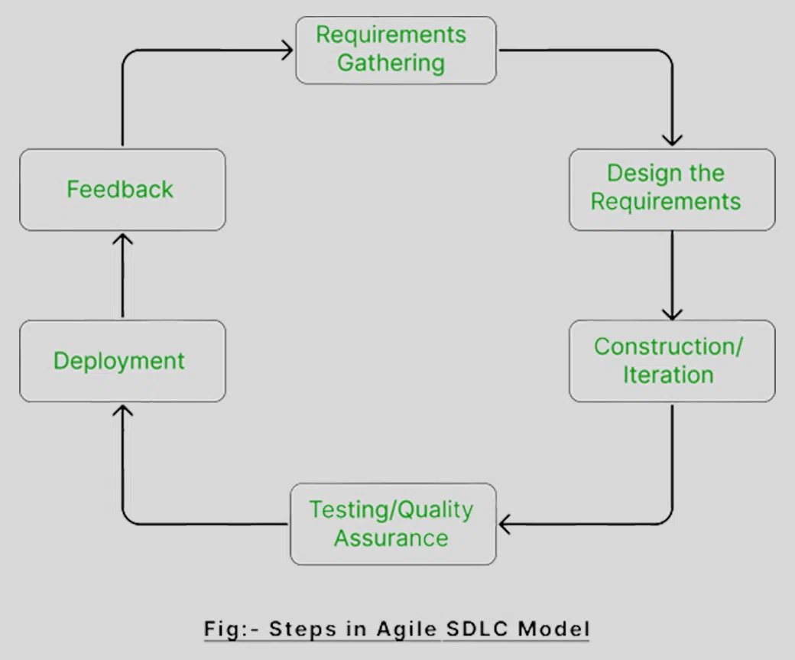
Figure 2: Agile Model
Advantages
Advantages | Explanation
Flexible | Requirements can change throughout development.
Faster delivery | Functional software is delivered after every sprint.
Continuous testing | Bugs are detected earlier, reducing maintenance cost.
Better customer satisfaction | Frequent feedback ensures the software meets user expectations.
Lower project risk | Problems can be identified and corrected during development.
Disadvantages
Disadvantages | Explanation
Difficult cost estimation | Changing requirements make budgeting more challenging.
Requires experienced developers | Teams must communicate effectively and manage frequent changes.
Less formal documentation | Some Agile teams focus more on software than documentation.
Requires customer participation | Continuous feedback from stakeholders is essential.

1.3 Spiral Model
Definition
- The spiral model combines the iterative model's small repeated cycles with the waterfall model's linear sequential flow to prioritize risk analysis. You can use the spiral model to ensure software's gradual release and improvement by building prototypes at each phase.
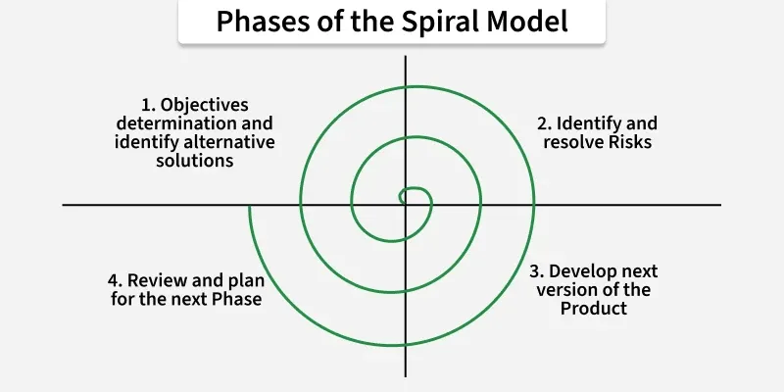
Figure 3: Spiral Model
Advantages
Advantages | Explanation
Excellent risk management | Risks are identified and reduced early.
Suitable for complex systems | Supports large-scale and high-risk projects.
Continuous improvement | Every iteration improves the previous version.
Flexible requirements | Requirements may evolve throughout development.
Disadvantages
Disadvantages | Explanation
Expensive | Requires significant resources and experienced managers.
Complex management | Difficult for small development teams.
Long development cycle | Multiple iterations increase project duration.
Not suitable for small projects | The overhead is unnecessary for simple applications.

2 Software Development Tools
Project Management Tools
2.1 Microsoft Project
Definition
Microsoft Project is a project management tool used to schedule tasks, allocate resources, monitor progress, and manage project timelines.

Figure 4: Microsoft Project
Advantages
Advantages | Explanation
Gantt Charts | Visualises the project schedule clearly.
Task Dependencies | Defines relationships between development activities.
Resource Allocation | Assigns work efficiently among team members.
Progress Monitoring | Tracks project completion percentage and milestones.
Disadvantages
Disadvantages | Explanation
Expensive | Requires a commercial licence.
Learning curve | Beginners need time to master all features.
Heavy software | May consume considerable system resources.

2.2 Jira
Jira is an Agile project management platform developed by Atlassian.

Figure 5: Jira
Advantages | Explanation
Sprint Planning | Supports Agile development effectively.
Bug Tracking | Records and monitors software defects.
Team Collaboration | Allows developers to coordinate tasks easily.
Reporting | Generates project progress reports automatically.
Disadvantages
Disadvantages | Explanation
Complex interface | New users may require training.
Subscription cost | Advanced features require paid plans.
Configuration effort | Initial setup can be time-consuming.

Development Tools
2.3 Android Studio
Android Studio is Google's official Integrated Development Environment (IDE) for Android application development.

Figure 6: Android Studio
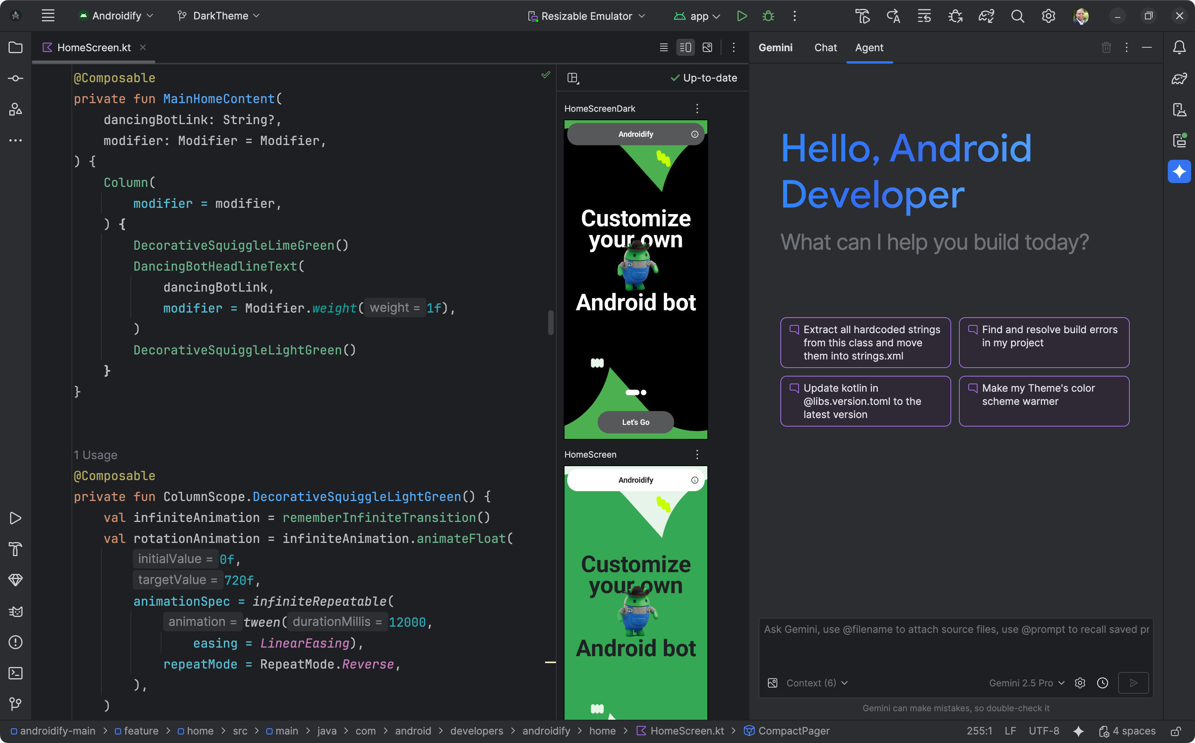
Figure 7: Android Studio code
Advantages
Advantages | Explanation
Official Android IDE | Fully supported by Google.
Intelligent Code Editor | Improves programming productivity.
Android Emulator | Tests applications without physical devices.
Built-in Debugger | Simplifies bug identification.
Firebase Integration | Supports cloud services and authentication.
Disadvantages
Disadvantages | Explanation
High hardware requirements | Requires sufficient RAM and CPU resources.
Large installation size | Occupies significant disk space.
Slow startup | May take time to load large projects.

2.4 Git & GitHub
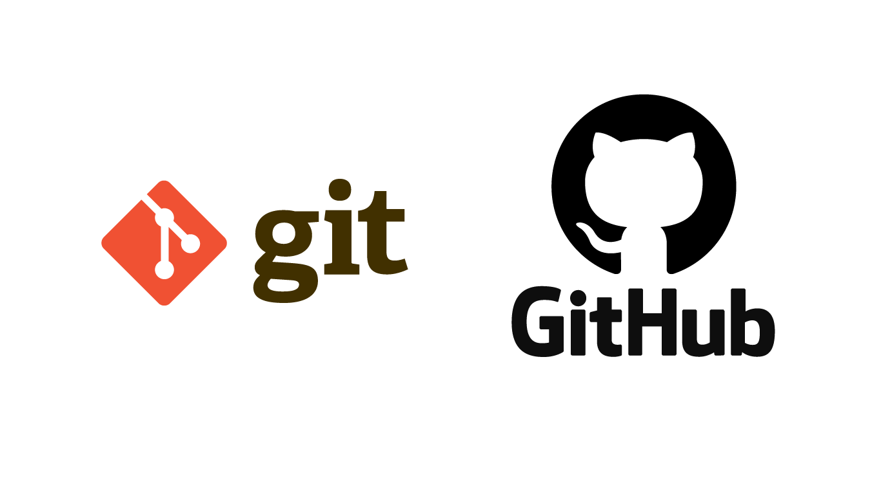
Git is a distributed version control system, while GitHub is a cloud platform for hosting Git repositories and facilitating team collaboration.

Figure 8: Git & GitHub
Advantages
Advantages | Explanation
Version Control | Maintains complete development history.
Collaboration | Supports multiple developers working simultaneously.
Backup | Prevents source code loss through cloud storage.
Branch Management | Allows independent feature development.
Code Review | Pull Requests improve software quality.
Disadvantages
Disadvantages | Explanation
Learning Git commands | Beginners require time to understand version control concepts.
Merge Conflicts | Simultaneous modifications may require manual conflict resolution.
Internet dependency | GitHub collaboration requires network access.

M2. Justifying development tools and development methodology selected

1. Justification for Selecting the Agile SDLC Model
Criteria | Justification
Project Requirements | The AI Study Mentor application is expected to evolve during development as new AI features and user feedback become available. Agile supports changing requirements without disrupting the entire project.
Project Timeline | The project has a limited development period of 14 weeks. Agile divides the work into short sprints, allowing the team to deliver a Minimum Viable Product (MVP) first and gradually add advanced features.
Team Experience | The development team consists of junior developers. Agile promotes teamwork, daily communication, and continuous learning, enabling members to improve their skills throughout the project.
Testing Process | Agile encourages continuous testing after every sprint, helping identify defects early and reducing the cost of fixing bugs compared with traditional development models.
Risk Management | Frequent reviews and customer feedback allow the team to identify project risks early and adjust the development plan when necessary.
Conclusion | Based on the project characteristics, Agile is the most suitable SDLC model because it provides flexibility, continuous improvement, faster delivery, and better collaboration throughout the development lifecycle.
Agile was selected because it allows the team to develop the AI Study Mentor application in short sprints and respond quickly to changing requirements. Continuous testing and regular feedback also help improve software quality throughout the project. Therefore, Agile is the most suitable methodology for this project.

2. Justification for Selecting Microsoft Project
Criteria | Justification
Project Planning | Microsoft Project provides Gantt Charts and Work Breakdown Structure (WBS) to organise project activities clearly.
Schedule Management | It helps monitor the 14-week development schedule and ensures project milestones are completed on time.
Task Dependency | Dependencies between tasks can be defined, allowing better planning and reducing scheduling conflicts.
Progress Tracking | The project manager can easily monitor completed tasks and identify delays.
Conclusion | Microsoft Project is suitable because it improves project planning, scheduling, resource allocation, and progress monitoring.
Microsoft Project was chosen because it helps the team plan tasks, manage the project schedule, and monitor progress effectively. Its Gantt Chart and task management features ensure the project is completed within the 14-week timeline.

3. Justification for Selecting Android Studio
Criteria | Justification
Platform Support | AI Study Mentor is an Android mobile application; Android Studio is Google's official IDE for Android development.
Development Efficiency | It provides code completion, debugging tools, UI Designer, and Android Emulator, increasing developer productivity.
AI Integration | Android Studio supports integration with AI APIs, Firebase, and local databases, which are essential for implementing AI-powered learning features.
Testing | Built-in emulators allow testing on multiple Android devices without requiring physical hardware.
Conclusion | Android Studio is the most appropriate development environment because it offers complete tools for building, testing, and deploying Android applications.
Android Studio was selected because it is the official IDE for Android development. It provides built-in tools such as the Android Emulator, Debugger, and Firebase integration, making application development and testing more efficient.

4. Justification for Selecting Git & GitHub
Criteria | Justification
Version Control | Git records every code change, making it easy to restore previous versions if necessary.
Team Collaboration | GitHub allows multiple developers to work on different branches simultaneously without affecting the main source code.
Code Review | Pull Requests help team members review code before merging, improving software quality.
Backup & Security | Cloud repositories reduce the risk of losing source code and maintain a complete development history.
Conclusion | Git & GitHub are ideal for collaborative software development because they support version control, teamwork, and code management efficiently.
Git and GitHub were selected because they support version control and team collaboration. They allow developers to track code changes, work on separate branches, and merge code safely, improving software quality and reducing development risks.

Activity 3 (M1)

M1. Analyse a business- related problem using appropriate methods to produce a well-structured software design document

1. What is OOAD?
Object-Oriented Analysis and Design (OOAD) is a software design approach that models a system using real-world objects. It first focuses on understanding system requirements, then identifying objects and defining how they interact. OOAD is based on object-oriented programming principles and combines Object-Oriented Analysis (OOA) and Object-Oriented Design (OOD). (geeksforgeeks, 2026)
Example:
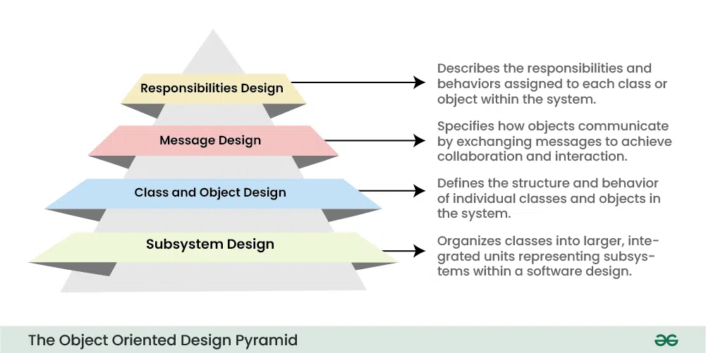
Figure 9: What is OOAD?
- The Subsystem Layer: It represents the subsystem that enables software to achieve user requirements and implement technical frameworks that meet user needs.
- The Class and Object Layer: It represents the class hierarchies that enable the system to develop using generalization and specialization. This layer also represents each object.
- The Message Layer: This layer deals with how objects interact with each other. It includes messages sent between objects, method calls, and the flow of control within the system.
- The Responsibilities Layer: It focuses on the responsibilities of individual objects. This includes defining the behavior of each class, specifying what each object is responsible for, and how it responds to messages.

2. What is UML?
Unified Modeling Language (UML) is a general-purpose modeling language. The main aim of UML is to define a standard way to visualize the way a system has been designed. It is quite similar to blueprints used in other fields of engineering. UML is not a programming language, it is rather a visual language. (geeksforgeeks, Unified Modeling Language (UML) Diagrams, 2026)
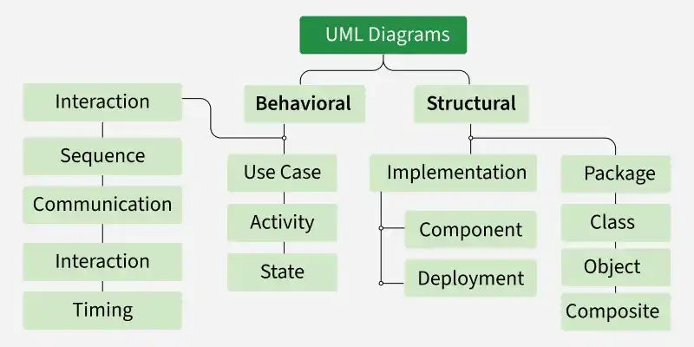
Figure 10: What is UML?

Need of UML
UML is essential for clearly visualizing and communicating system design among different stakeholders involved in a project.
The benefits of applying OOAD and UML to a project
OOAD:
Benefit | Explanation
Modularity | Easier maintenance
Reusability | Classes can be reused
Scalability | Easy to add new features
Maintainability | Easier debugging
Flexibility | Supports future AI features

UML:
Benefit | Description
Better communication | Developers understand the design
Visualization | Easy to understand system structure
Documentation | Clear software documentation
Planning | Reduces coding errors

3. Use Case Diagram
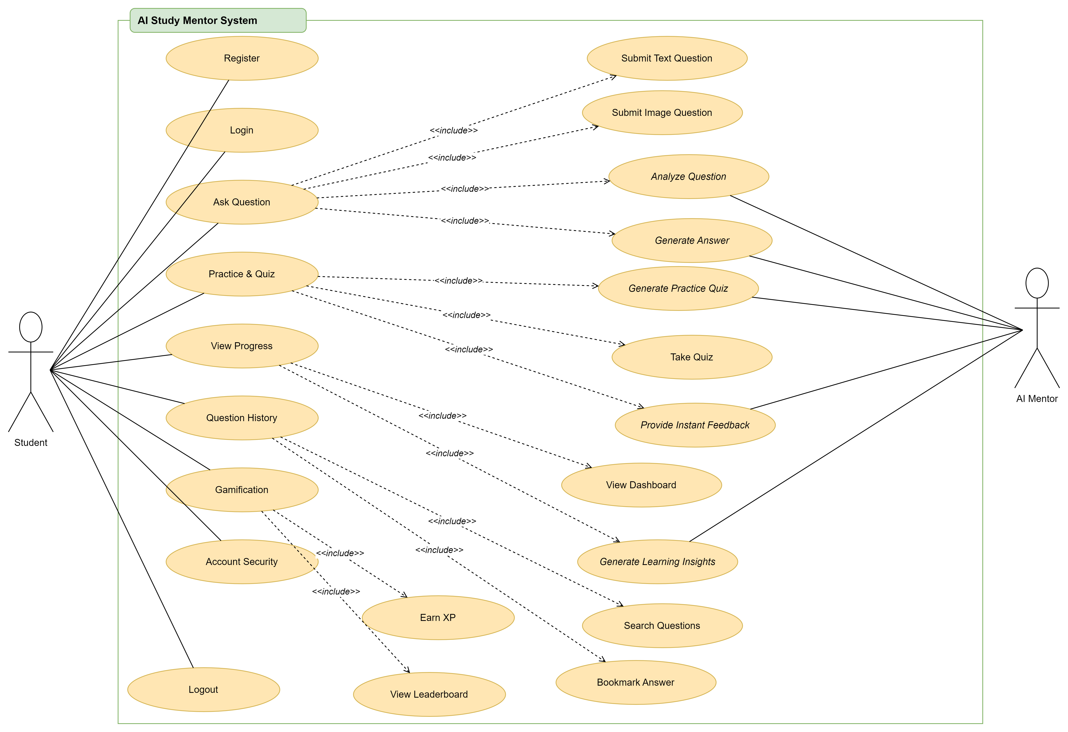
Figure 11: Use Case Diagram
The Use Case Diagram clearly identifies the interactions between users and the system. Students can register, log in, complete quizzes, ask AI questions, and view learning progress, while administrators manage users and learning content. This design ensures that all functional requirements are covered and reduces misunderstandings during development.
Main Components
- Actors: These are external entities that interact with the system (represented by the pink stick figures).
  - Students: The primary user actor who actively interacts with the system to learn, ask questions, and practice.
  - AI Mentor: An automated system actor that processes requests, analyzes questions, and provides answers or quizzes back to the students.
- System Boundary: The large green rectangular box labeled "AI Study Mentor System". It defines the scope of the system; everything inside the box represents the system's functionalities (Use Cases), while everything outside represents external actors.
- Use Cases: The yellow ellipses inside the system boundary. Each ellipse represents a specific function or feature that the system provides.
Meaning of Relationships
There are two primary types of connection lines used in this diagram:
Solid Lines (Association)
- Meaning: Represents a direct interaction between an Actor and a Use Case.
- Examples:
  - Students is connected to Register, Login, Ask Question, etc., meaning the student is the one initiating and performing these actions.
  - AI Mentor is connected to Analyze Question, Generate Answer, Generate Practice Quiz, and Provide Instant Feedback, meaning the AI system automatically handles these background processes to deliver results.
Dashed Arrows with <<include>> (Include Relationship)
- Meaning: Directed from a base Use Case to an included Use Case. It means that the base Use Case cannot function or be completed without automatically triggering the included Use Case.
- Detailed breakdown of the <<include>> clusters:
Base Use Case | Included Use Case(s) | Explanation
Ask Question | Submit Text QuestionSubmit Image QuestionAnalyze QuestionGenerate Answer | When a student asks a question, they must choose to submit it via text or image. Consequently, the system must analyze the question and generate an answer.
Practice & Quiz | Generate Practice QuizTake QuizProvide Instant Feedback | Accessing this feature triggers the system to generate a quiz, allows the student to take it, and mandates that the system provides instant feedback upon completion.
View Progress | View DashboardGenerate Learning Insights | Viewing academic progress automatically opens the visual dashboard and triggers the system to generate deep learning insights.
Question History | Search QuestionsBookmark Answer | Inside the history module, the capabilities to search through old questions and bookmark specific answers are included.
Gamification | Earn XPView Leaderboard | Note: Looking closely at image_09ba21.png, the dashed arrows for Earn XP and View Leaderboard accidentally originate from Account Security due to a minor diagramming layout error. Logically and contextually, these two features are included under Gamification, rewarding students with experience points and allowing them to see their rank.

4. Class diagrams
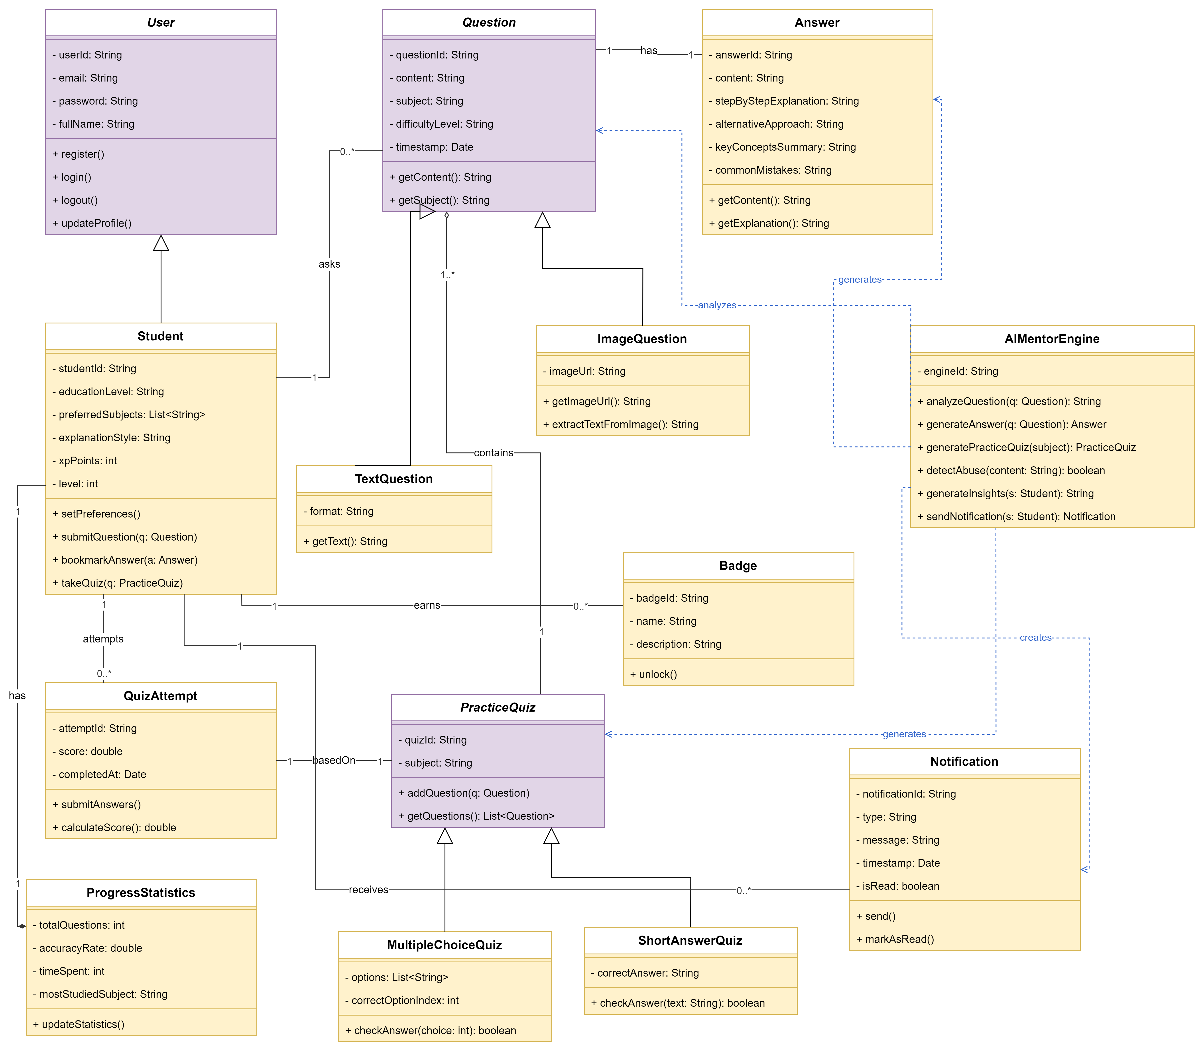
Figure 12: Class diagrams
The Class Diagram organizes the relationships between classes such as User, Quiz, Question, Result, and AI Service. This structure reduces data redundancy and simplifies future maintenance. It also supports object-oriented programming principles, making the application easier to develop and expand.
The structural architecture of the AI Study Mentor system consists of the following key domains.
User Management Domain:
  - User (Base Class): Acts as the generalized parent class containing shared profile characteristics like userId, email, password, and fullName. It exposes fundamental actions such as register(), login(), logout(), and updateProfile().
  - Student (Subclass): Inherits directly from User. It captures student-specific personalization metrics such as educationLevel, preferredSubjects, explanationStyle, and gamification stats (xpPoints, level). It initiates active business flows like submitQuestion(), bookmarkAnswer(), and takeQuiz().
- Question Formulation Domain:
  - Question (Base Class): Holds abstract query values including questionId, content, subject, difficultyLevel, and timestamp.
  - TextQuestion & ImageQuestion (Subclasses): Inherit from Question. TextQuestion manages plain textual formats via getText(). ImageQuestion stores an imageUrl and encapsulates optical character recognition (OCR) logic via extractTextFromImage() to support multi-modal submissions.
- Core Logic Powerhouse:
  - AIMentorEngine: A stateless service class running the primary AI processing logic: analyzing questions, generating step-by-step answers or practice quizzes, running moderation checks (detectAbuse()), and triggering automated Notification entities.
- Answer Delivery Domain:
  - Answer: Stores highly structured, multi-dimensional AI outputs instead of simple text blocks. It holds a stepByStepExplanation, alternativeApproach, keyConceptsSummary, and warns users about commonMistakes.
- Assessment & Gamification Domain:
  - PracticeQuiz (Base Class): Represents an AI-generated assessment containing a unique quizId and a designated subject.
  - MultipleChoiceQuiz & ShortAnswerQuiz (Subclasses): Inherit from PracticeQuiz. MultipleChoiceQuiz contains an options list and checks indices, while ShortAnswerQuiz handles manual text evaluation via checkAnswer().
  - QuizAttempt: Tracks execution metrics every time a student sits for a quiz, storing individual score and completedAt values.
  - ProgressStatistics: Aggregates performance indicators (accuracyRate, timeSpent, mostStudiedSubject) over time.
  - Badge & Notification: Represent gamified rewards (unlock()) and dynamic system alerts (send(), markAsRead()).
4.2. Meaning of Structural Relationships & Multiplicities
- Inheritance / Generalization (Solid line with an unfilled arrow head):
  - Student $\rightarrow$ User: A Student is a specialized type of User.
  - TextQuestion / ImageQuestion $\rightarrow$ Question: Implements polymorphic behavior for different user input types.
  - MultipleChoiceQuiz / ShortAnswerQuiz $\rightarrow$ PracticeQuiz: Diverges assessment types to evaluate students via multiple choices or text inputs.
- Association & Multiplicities (Solid lines with directional labels):
  - Student — [asks 1 $\rightarrow$ 0..*] — Question: One specific student can ask zero to many (0..*) questions, but every logged question must cleanly resolve back to exactly 1 student profile.
  - Question — [has 1 $\rightarrow$ 1] — Answer: A strict, transactional one-to-one mapping ensuring every question gets exactly 1 structured AI explanation.
  - Student — [earns 1 $\rightarrow$ 0..*] — Badge: A single student earns zero to multiple badges over time.
  - Student — [attempts 1 $\rightarrow$ 0..*] — QuizAttempt: Tracks comprehensive learning history by linking multiple quiz sessions back to one unique student ID.
  - QuizAttempt — [basedOn 1 $\rightarrow$ 1] — PracticeQuiz: Every calculated scoring record must be strictly evaluated against exactly 1 concrete quiz configuration.
  - Student — [has 1 $\rightarrow$ 1] — ProgressStatistics: Tracks long-term performance updates tied explicitly to a single user.
  - PracticeQuiz — [contains 1 $\rightarrow$ 1..*] — Question: Aggregation showing that an AI quiz populates itself by collecting one or more validated questions.
  - Student — [receives 1 $\rightarrow$ 0..*] — Notification: Maps asynchronous updates or reminders directly to targeted student receivers.
- Dependency (Dashed arrows with functional labels):
  - AIMentorEngine $\dashrightarrow$ Question / Answer / PracticeQuiz / Notification: The background AI core temporarily accesses, processes, coordinates, or instantiates (analyzes, generates, creates) these entities without claiming permanent structural ownership over them.

5. Individual Discussion
5.1 Why the Overall System Design is Suitable
- As a member of the development team, I believe that the proposed system design provides a strong foundation for implementing the AI Study Mentor application. Before development begins, the team analysed the business requirements and transformed them into a structured software design using the Object-Oriented Analysis and Design (OOAD) approach and UML diagrams. This ensures that every major system function is planned clearly, reducing misunderstandings during implementation.
- The design also reflects the main objective of the project, which is to provide students with an AI-powered learning platform where they can ask questions, receive intelligent answers, practise with quizzes, and monitor their learning progress. Since all core requirements have been represented in the design, the development process can proceed in a systematic and organised manner.
5.2 Why the Use Case Diagram Works Well
- The Use Case Diagram is effective because it clearly identifies the interactions between the external actors and the AI Study Mentor system.
- The diagram includes two actors:
- Student
- AI Mentor
- The Student actor represents the primary user who performs learning activities such as registration, login, asking questions, viewing learning progress, participating in quizzes, and managing account security. Meanwhile, the AI Mentor represents the intelligent engine responsible for analysing questions, generating answers, creating quizzes, and providing learning insights.
- The use cases are organised into logical modules, including Authentication, Question & Answer, Practice & Quiz, Progress Tracking, History, Gamification, and Account Management. This modular organisation makes the system easier to understand and allows developers to implement one module at a time.
- In addition, the use of <<include>> relationships helps eliminate duplicated functionality. For example, whenever a student submits a question, the system must first analyse the question before generating an answer. Representing this behaviour using <<include>> improves consistency and reduces implementation complexity.
- Overall, the Use Case Diagram provides a clear representation of the system's functional requirements and serves as a communication tool between developers, project managers, and stakeholders.
5.3 Why the Class Diagram Works Well
- The Class Diagram provides an appropriate structural design for the AI Study Mentor application because it models the main business entities as independent classes.
- The design includes important classes such as Student, Question, Answer, PracticeQuiz, QuizAttempt, ProgressStatistics, Notification, Badge, and AIMentorEngine.
- Each class has a clearly defined responsibility. For example:
- Student manages user information and learning activities.
- Question stores questions submitted by students.
- Answer contains AI-generated responses.
- PracticeQuiz manages quiz information.
- QuizAttempt records quiz results.
- ProgressStatistics calculates learning performance.
- Notification handles reminders and announcements.
- Badge supports the gamification system.
- AIMentorEngine performs AI processing and intelligent recommendations.
- The relationships between classes also accurately represent the business logic of the application. One student can submit multiple questions, each question has one answer, and students can complete multiple quizzes. These relationships improve software consistency and simplify database implementation.
- From a software engineering perspective, separating responsibilities into individual classes follows the Single Responsibility Principle (SRP), making the software easier to maintain, test, and extend in future versions.
5.4 Why the OOAD Approach is Suitable
- The team selected the Object-Oriented Analysis and Design approach because it models the software using real-world objects instead of individual functions.
- This approach improves software modularity by separating the application into reusable components. Each class contains its own data and behaviours, allowing developers to work independently on different modules without affecting the rest of the system.
- Another advantage of OOAD is maintainability. If new AI services need to be added in future versions, such as voice interaction or document summarisation, new classes can be introduced without redesigning the entire application.
- Furthermore, OOAD supports scalability. As the number of users increases or additional educational features are introduced, the existing object-oriented architecture can be expanded more easily than a procedural design.
5.5 Why UML is an Effective Modelling Tool
- UML plays an important role throughout the software development process because it provides a standard way of representing system requirements and software architecture.
- Instead of discussing software only through written descriptions, developers can visualise the system using diagrams. This improves communication among team members and reduces misunderstandings during implementation.
- For this project, the Use Case Diagram explains what the system should do, while the Class Diagram explains how the system is organised internally.
- These diagrams also serve as technical documentation that can be reused during coding, testing, maintenance, and future system upgrades.
5.6 Why the Test Plan Supports the Project
- A comprehensive test plan is essential for ensuring software quality before deployment.
- The proposed testing strategy covers the application's major functional modules, including authentication, AI question answering, quiz generation, progress tracking, notifications, and gamification.
- Testing each module individually before integration helps identify defects early and reduces the cost of fixing bugs later in development.
- The test plan also includes User Acceptance Testing (UAT), allowing real students to evaluate whether the application satisfies their learning needs. This feedback is particularly important because the project focuses on improving students' learning experiences rather than simply delivering technical functionality.
- 5.7 Overall Evaluation
- From my perspective as a member of the development team, I believe the proposed design is well suited to the AI Study Mentor project because it successfully combines business requirements with object-oriented software engineering principles.
- The Use Case Diagram accurately models user interactions, while the Class Diagram provides a clear structural architecture for implementation. The OOAD methodology promotes modularity, maintainability, and scalability, and UML offers an effective way to visualise and document the system before coding begins. In addition, the proposed test plan ensures that software quality can be verified throughout the development process.
- Although the design may require minor refinements as user feedback is collected during development, it already provides a solid and practical foundation for building a reliable, maintainable, and scalable AI-powered learning application. Therefore, I believe the current design will support the successful implementation of the AI Study Mentor project and can be extended easily to accommodate future enhancements.

Activity 4 (D1)

D1. Evaluate the solution to a business-related problem and the preferred software development methodology by comparing the various software development tools and techniques researched
1.1 Evaluation of SDLC Models (Agile vs Waterfall vs V-Model)
Comparison of SDLC Models
Criteria | Agile (Selected) | Waterfall | V-Model
Development Process | Iterative and incremental | Sequential | Sequential with testing
Requirement Changes | Easy to modify | Difficult after planning | Limited flexibility
Testing | Continuous during each sprint | Mainly after development | Testing follows each development phase
Best For | Dynamic projects | Stable projects | Safety-critical systems
Evaluation
Although all three SDLC models provide a structured software development process, they differ significantly in flexibility and change management.
Waterfall requires all requirements to be defined before development begins, making it difficult to accommodate new AI features or user feedback. Similarly, the V-Model improves software quality through systematic testing but still follows a rigid sequence that limits changes during development.
In contrast, Agile supports iterative development, allowing the team to improve AI features, quizzes, and learning recommendations after each sprint. This flexibility is particularly important because user requirements for an AI learning platform may evolve throughout the project.
Conclusion
Therefore, Agile is the most suitable methodology because it offers greater flexibility, continuous feedback, and faster adaptation than both Waterfall and the V-Model.
1.2 Evaluation of Development Tools
Android Studio vs VS Code
Criteria | Android Studio | VS Code
Android Support | Official IDE | Requires extensions
Emulator | Built-in | External tools
Debugging | Integrated | Manual configuration
Productivity | High | Medium
Evaluation
Both Android Studio and VS Code can be used for Android development. However, Android Studio provides a complete development environment with integrated debugging, emulator support, and Android SDK tools. VS Code is lightweight but requires additional configuration before development can begin.
For the AI Study Mentor project, Android Studio reduces development time and simplifies testing, making it the more efficient choice.
Conclusion
Android Studio is more suitable because it improves development efficiency and provides complete Android development support.
Java vs Kotlin
Criteria | Java | Kotlin
Learning Curve | Familiar to team | Newer language
Community Support | Very large | Growing
Syntax | More verbose | More concise
Stability | High | High
Evaluation
Both Java and Kotlin are officially supported for Android development. However, the project team already has stronger experience with Java, allowing development to begin immediately without additional training. Although Kotlin provides shorter syntax and built-in null safety, adopting it would increase the learning curve during a limited project schedule.
Conclusion
Java is the better choice because it matches the team's skills while providing a stable and reliable development environment.
MySQL vs MongoDB
Criteria | MySQL | MongoDB
Database Type | Relational | NoSQL
Data Relationships | Strong | Flexible
Foreign Keys | Supported | Not supported
Data Integrity | High | Moderate
Evaluation
The main difference between MySQL and MongoDB is how they manage data relationships. MySQL uses relational tables and foreign keys to maintain data consistency, while MongoDB stores flexible documents without strict relationships.
Since AI Study Mentor manages related entities such as students, quizzes, questions, and results, maintaining data integrity is essential. Therefore, MySQL better satisfies the project's requirements.
Conclusion
MySQL is the preferred database because it provides stronger consistency and relationship management.
GitHub vs SVN
Criteria | GitHub | SVN
Repository | Distributed | Centralized
Branching | Yes | Limited
Pull Requests | Supported | Not available
Team Collaboration | Excellent | Moderate
Evaluation
Both GitHub and SVN provide version control, but they differ in collaboration capabilities. GitHub allows developers to work independently through feature branches before merging their code, whereas SVN relies on a centralized workflow that increases the likelihood of conflicts.
For a student team developing multiple modules simultaneously, GitHub offers more efficient collaboration and easier source code management.
Conclusion
GitHub is the preferred version control system because it supports modern collaborative software development.
1.3 Overall Evaluation
The selected solution effectively addresses BrightPath Learning's business requirements by combining an appropriate development methodology with suitable development tools. Compared with the alternatives, Agile provides greater flexibility, Android Studio improves development efficiency, Java matches the team's technical skills, MySQL ensures reliable data management, and GitHub enhances collaboration. Together, these technologies provide the best balance of maintainability, scalability, and software quality for the AI Study Mentor project.

Assignment 2

Activity 1 (P4 + M3)
Introduction
Developing a successful business application requires more than implementing technical features; it also depends on understanding user needs and continuously improving the proposed solution through feedback. Before the application is fully developed, it is essential to conduct a peer review and collect opinions from potential users to ensure that the system meets both functional and business requirements.
This activity focuses on evaluating the proposed solution for the BrightPath Learning business application through a structured survey. A group of participants representing different roles, such as administrators, teachers, students, and office staff, were invited to provide feedback on the system requirements, usability, functionality, interface design, and overall expectations. Their responses provide valuable insights into how well the proposed solution addresses real user needs.
The survey results are then interpreted and analysed to identify weaknesses, missing features, and areas requiring improvement. Based on these findings, appropriate recommendations are proposed to refine the system design and enhance the quality of the application before implementation. This evaluation process helps reduce development risks, improve user satisfaction, and ensure that the final application better aligns with the initial business objectives and user requirements.
1. Survey Participants
To evaluate the proposed solution and ensure it meets user requirements, a survey was conducted with 20 participants representing different roles, including administrators, teachers, students, and office staff. The participants vary in age, job position, and experience to provide diverse and objective feedback on the proposed business application.
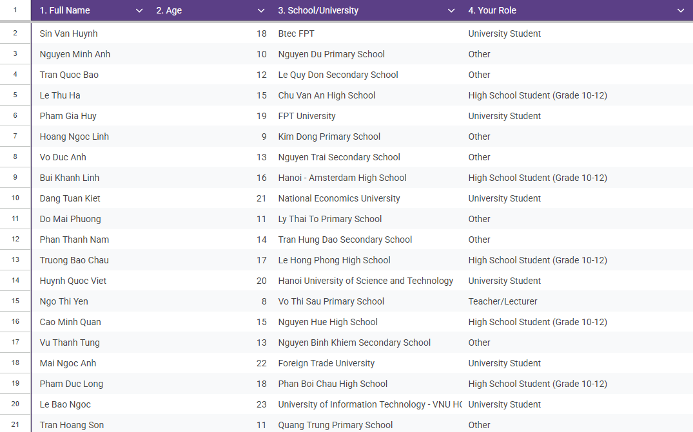

2. Survey Questionnaire
The survey was completed by 20 participants with different educational roles. Among them:
- 40% selected Other.
- 30% were University Students.
- 25% were High School Students (Grade 10–12).
- 5% were Teachers/Lecturers.
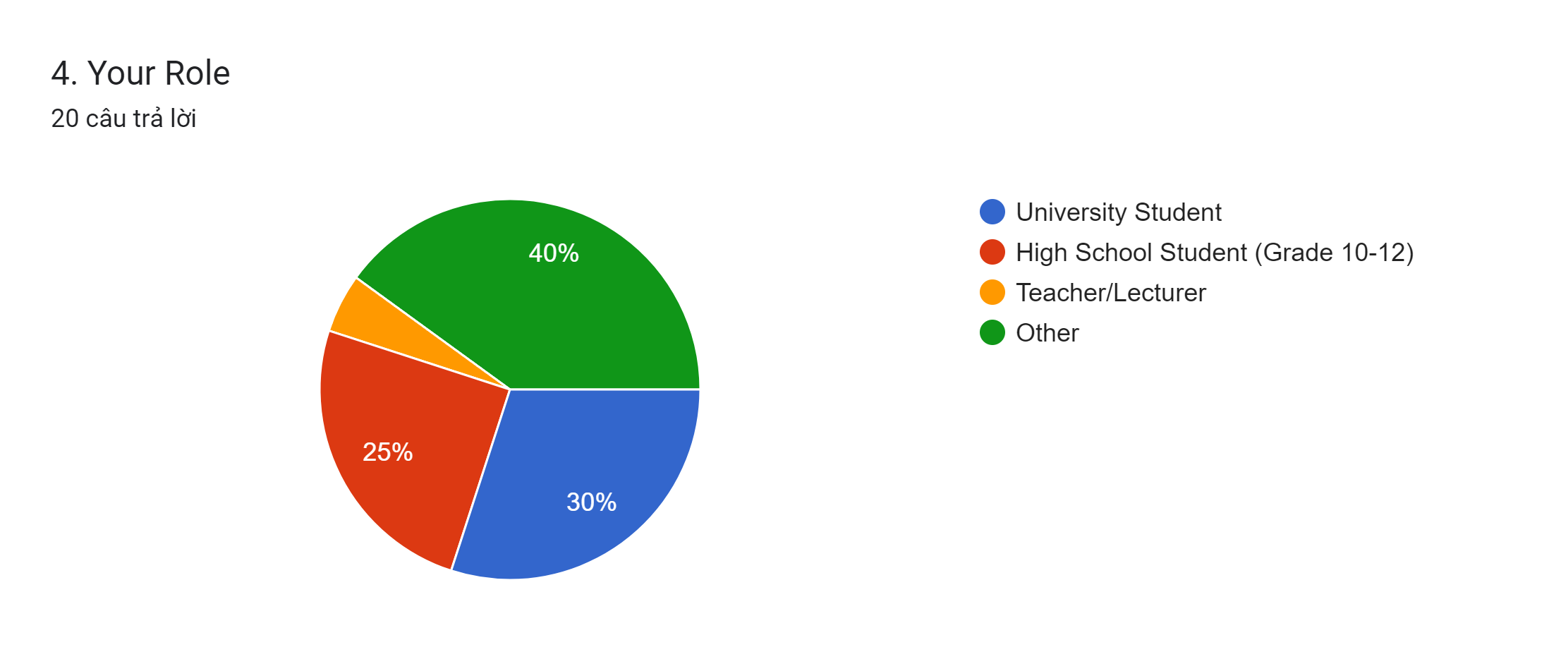

Question 5. How do you usually study? (Select all that apply)
The responses show that participants use various learning methods:
- Read textbooks/notes: 18 responses (90%)
- Use AI tools (ChatGPT, Gemini, etc.): 18 responses (90%)
- Watch video lectures: 14 responses (70%)
- Ask friends/teachers: 14 responses (70%)
- Search on Google: 12 responses (60%)
- Practice with exercises: 5 responses (25%)
- Other: 1 response (5%)
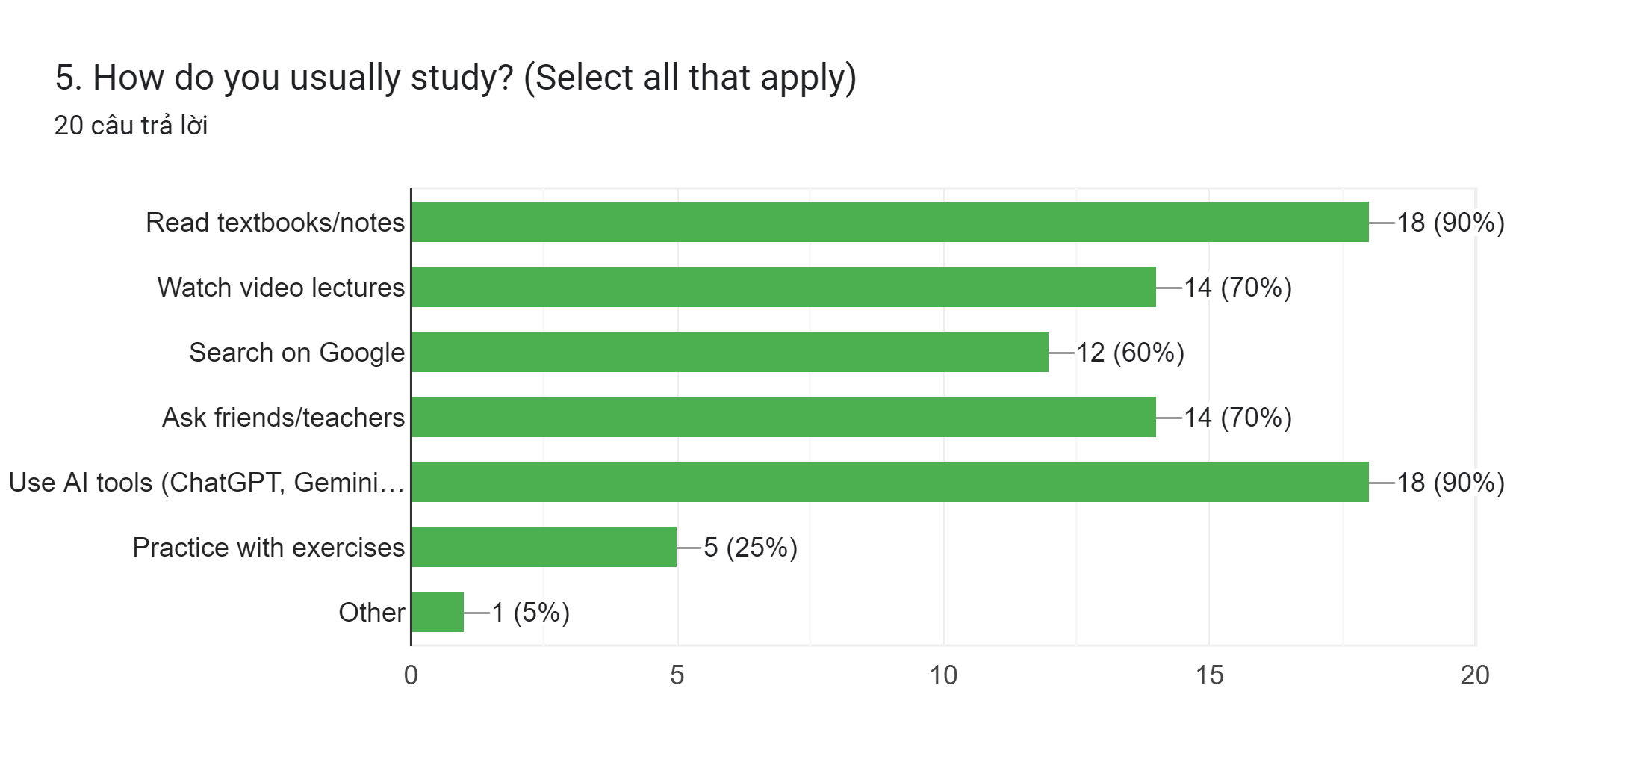

Question 6. What challenges do you face when studying? (Select all that apply)
The most common learning challenges reported by participants are:
- Difficulty understanding lectures: 15 responses (75%)
- Don't know how to review effectively: 14 responses (70%)
- Lack of study materials: 13 responses (65%)
- Time management issues: 13 responses (65%)
- Lack of motivation: 11 responses (55%)
- No one to guide me: 11 responses (55%)
- Other: 3 responses (15%)
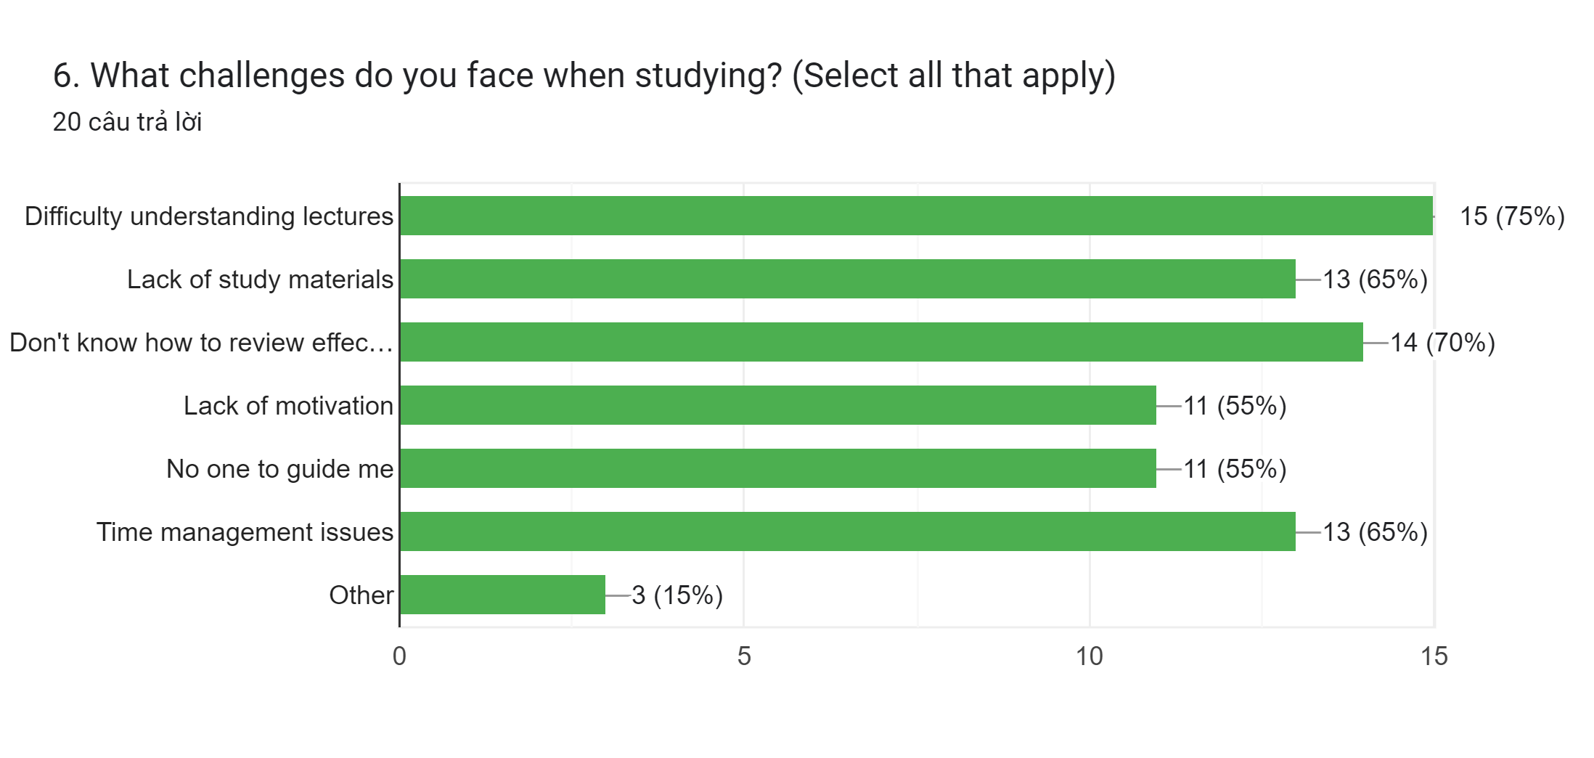

Question 7. Are you aware of AI-powered study tools?
The survey results indicate that:
- 55% use AI-powered study tools regularly.
- 40% know about them but rarely use them.
- 5% do not know about AI-powered study tools.
- 0% selected Not interested.
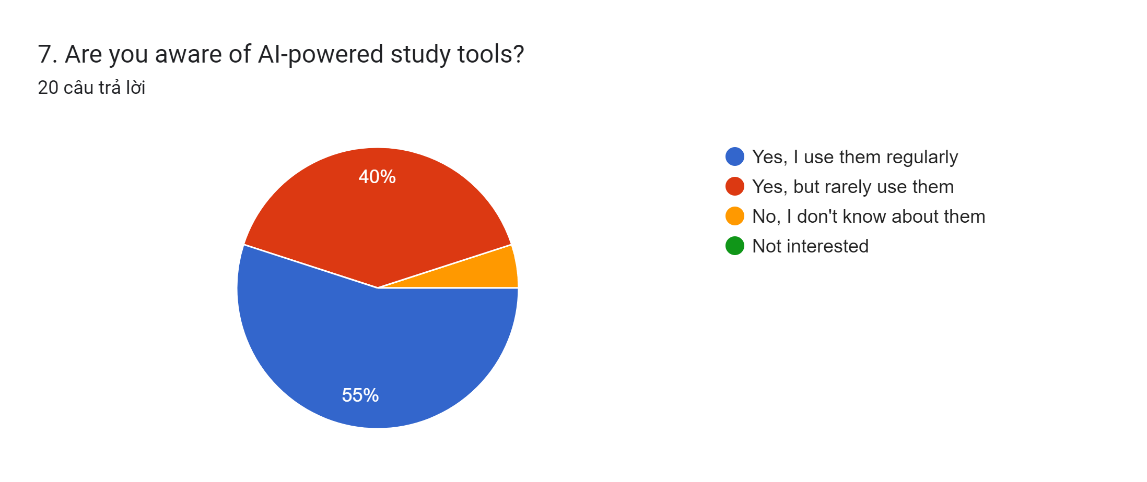

Question 8. Rate the "Ask AI Mentor" feature (Q&A with AI)
Participants rated the feature as follows:
- 4 points: 17 responses (85%)
- 3 points: 3 responses (15%)
- 2 points: 0 responses (0%)
- 1 point: 0 responses (0%)
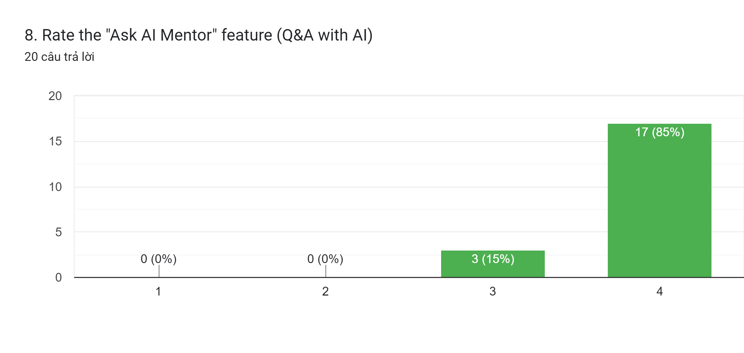

Question 9. Rate the "Quiz AI" feature (Auto-generated quizzes)
Participants rated the feature as follows:
- 3 points: 16 responses (80%)
- 2 points: 4 responses (20%)
- 1 point: 0 responses (0%)
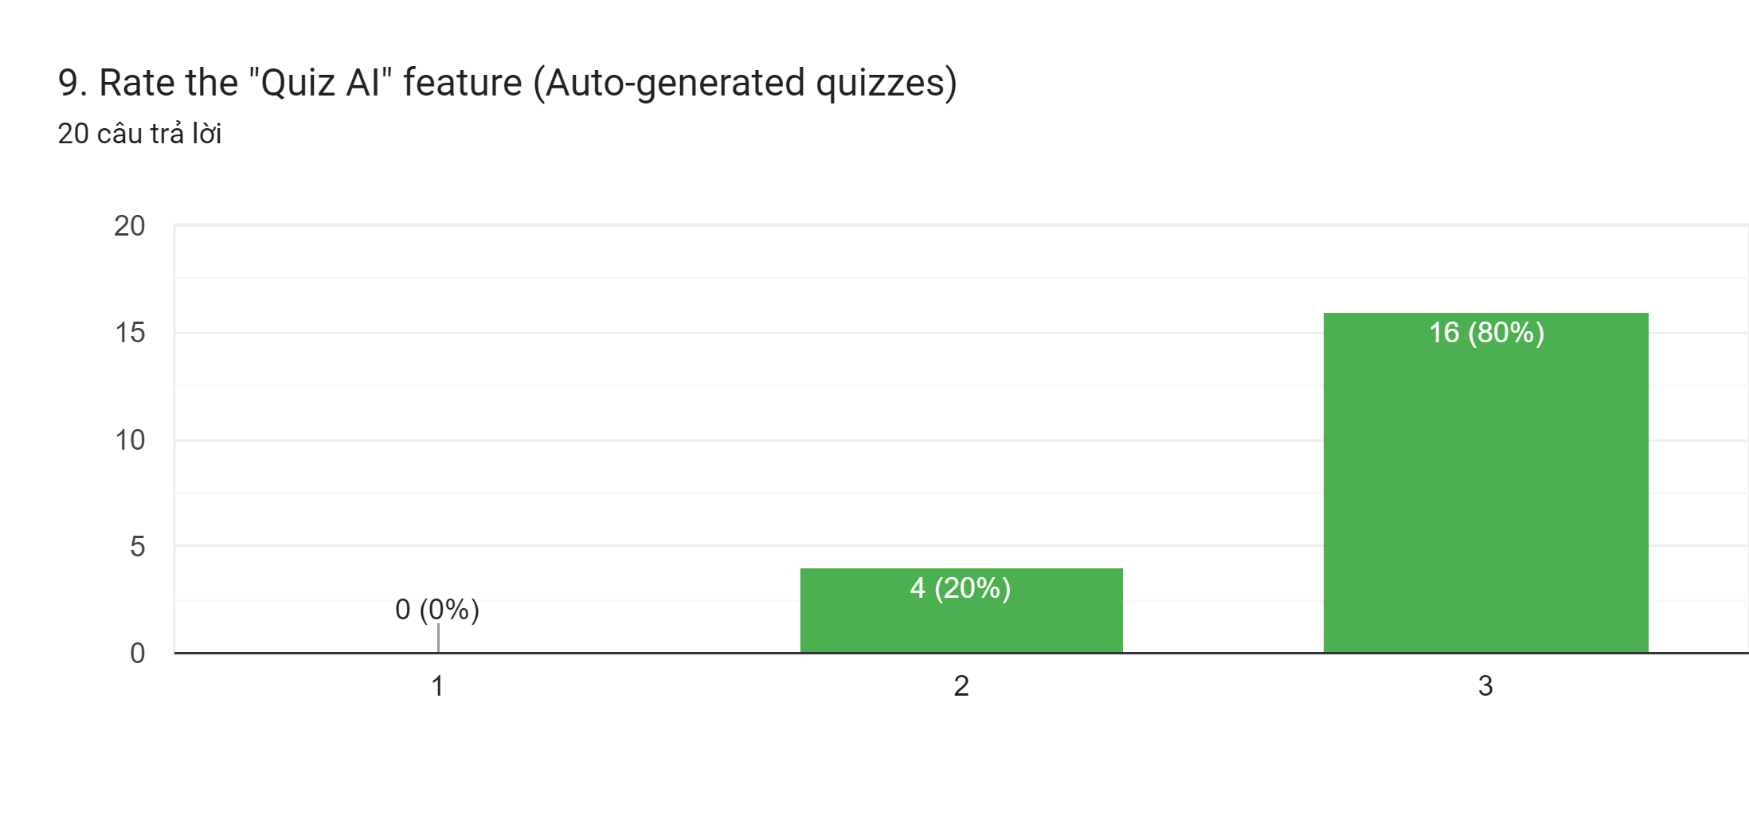

Question 10. Would you like to upload homework images for AI to explain?
The survey results show that:
- 75% answered Yes, definitely.
- 25% answered Maybe, I would try it.
- 0% answered Not interested.
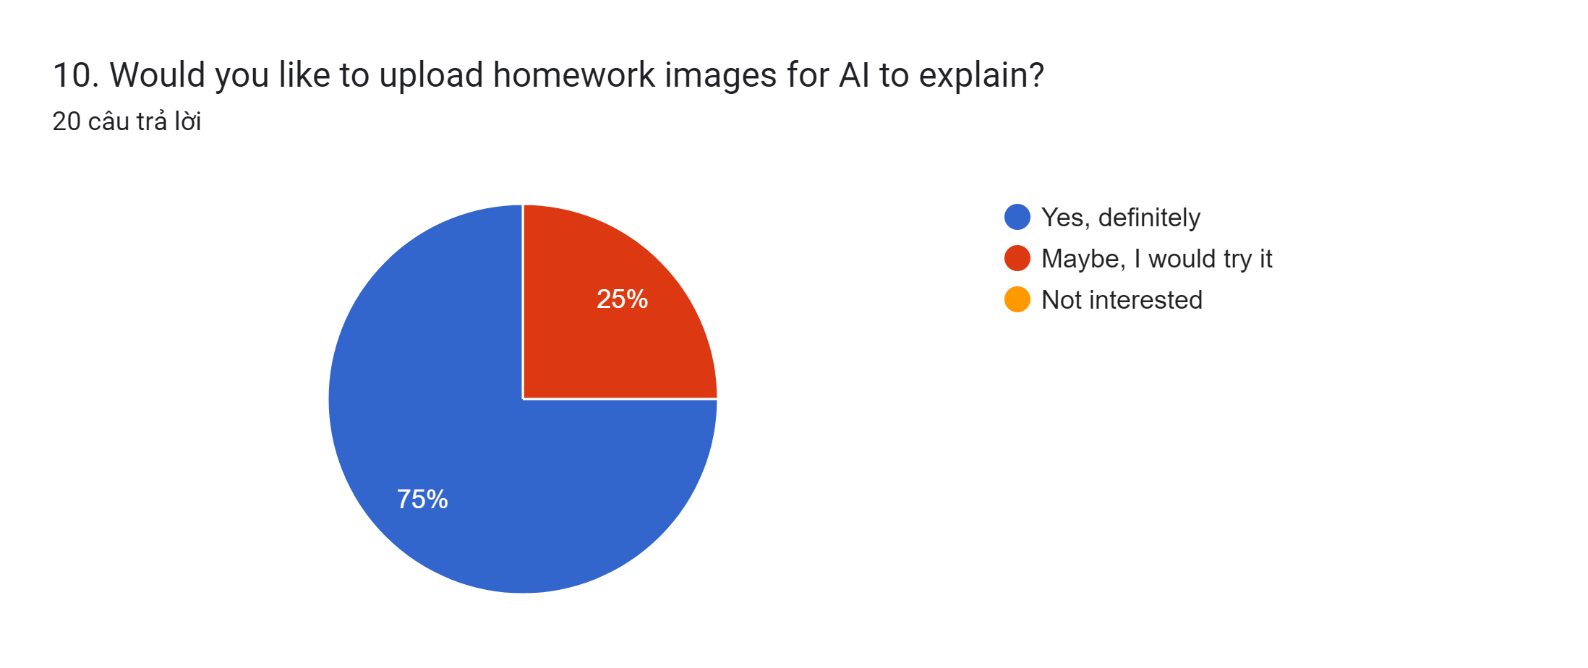

Question 11. Rate the "Leaderboard" feature (Compete with friends)
Participants rated the feature as follows:
- 4 points: 17 responses (85%)
- 3 points: 3 responses (15%)
- 2 points: 0 responses (0%)
- 1 point: 0 responses (0%)
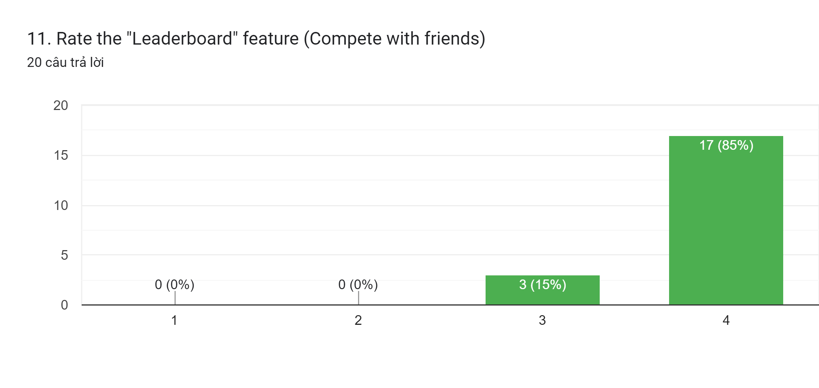

Question 13. What features would you like to see in the app? (Select all that apply)
Participants selected the following desired features:
- Study reminders: 18 responses (90%)
- Offline mode: 15 responses (75%)
- Study groups: 13 responses (65%)
- Share study materials: 11 responses (55%)
- Personalized learning path: 10 responses (50%)
- Multi-language support: 10 responses (50%)
- Other: 2 responses (10%)
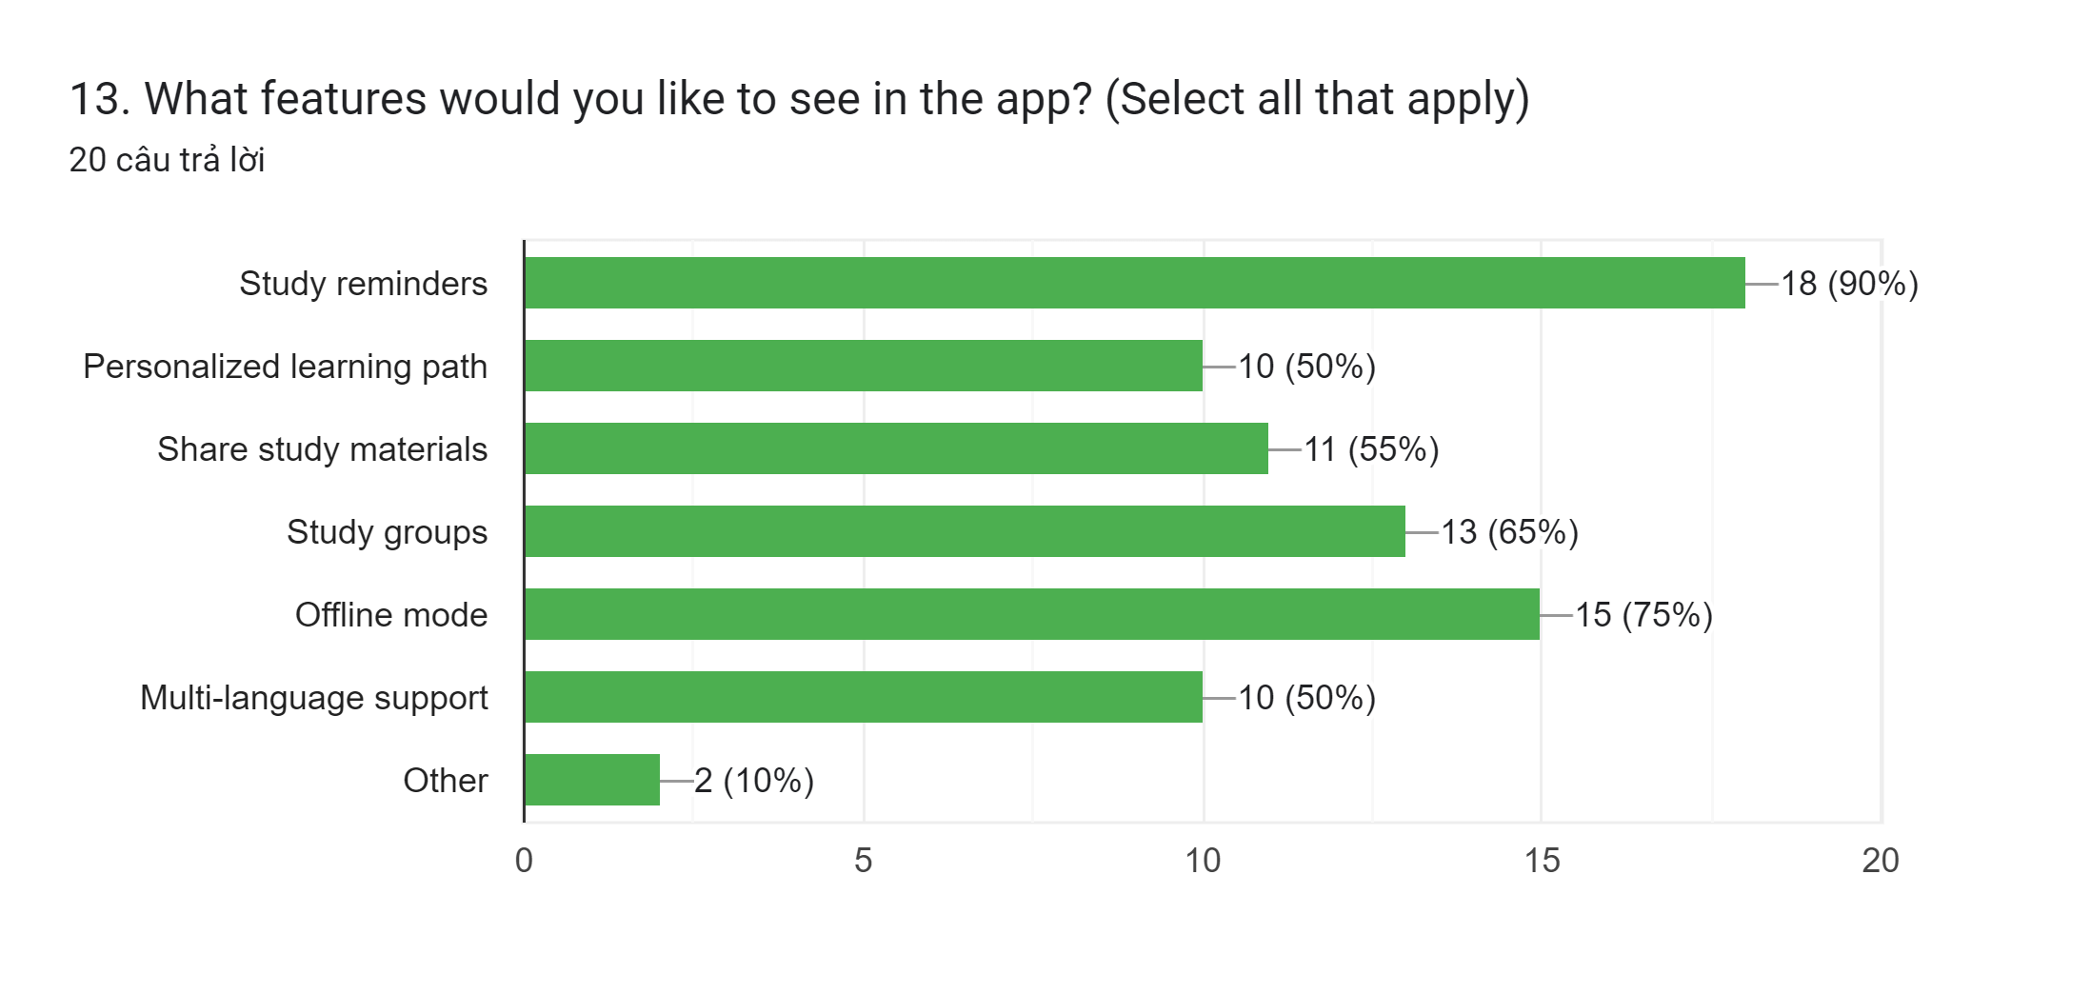

Question 14. Would you use this app if available on App Store/CH Play?
The survey results indicate that:
- 60% answered Yes, immediately.
- 25% answered Yes, if it's free.
- 15% answered Need to think about it.
- 0% answered No.
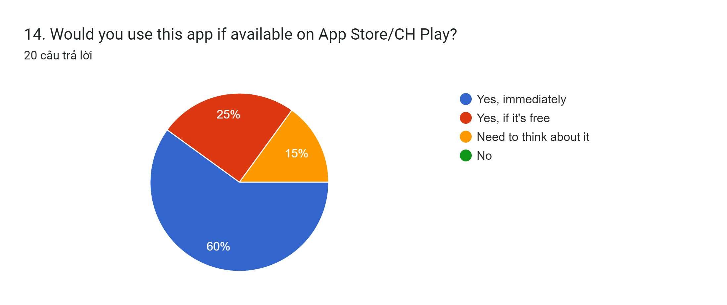
3. Analysis of Survey Results and Recommendations
The survey results provide valuable feedback on the proposed BrightPath Learning application. Overall, participants showed a positive attitude toward the system and expressed interest in AI-powered learning features. However, the survey also revealed several weaknesses and opportunities for improvement.
3.1 Identified Weaknesses
Weakness 1: Students have difficulty understanding lessons
According to the survey, 75% of participants reported that they have difficulty understanding lectures, while 70% stated that they do not know how to review lessons effectively. This indicates that many students require additional learning support beyond traditional classroom teaching.
Recommendation
- Improve the Ask AI Mentor feature to provide step-by-step explanations.
- Add personalized learning recommendations based on each student's learning progress.
- Provide learning summaries and revision suggestions after each lesson.
Weakness 2: Limited learning resources
The survey shows that 65% of respondents experience a lack of study materials, while 90% usually rely on textbooks or notes and 90% also use AI tools for learning. This suggests that students often need multiple learning resources.
Recommendation
- Build a digital learning resource library.
- Allow users to upload and share study materials.
- Integrate AI-generated learning content and recommended references.
Weakness 3: Time management and motivation
The results indicate that 65% of participants struggle with time management, and 55% report a lack of motivation when studying.
Recommendation
- Add Study Reminder notifications.
- Include study schedules and daily learning plans.
- Introduce a progress tracking system to encourage consistent learning.
Weakness 4: Lack of interaction and guidance
Approximately 55% of participants stated that they have no one to guide them during their learning process.
Recommendation
- Enhance the Ask AI Mentor feature with more detailed explanations.
- Add discussion groups where students can communicate and ask questions.
- Allow teachers to answer important questions through the application.
Weakness 5: Missing user-requested features
The survey shows that users would like several additional features, including:
- Study reminders (90%)
- Offline mode (75%)
- Study groups (65%)
- Share study materials (55%)
- Personalized learning paths (50%)
- Multi-language support (50%)
These features are not fully implemented in the current version of the application.
Recommendation
The next version of the application should prioritize implementing these requested features to improve usability and better satisfy user needs.

Activity 3 (P6 + M5 +D2)
Evaluate the suitability of your team’s solution in relation to the needs of BrightPath Learning. Your evaluation must include:

1. Critical review of the systems investigation process

References
amazon. (2026). What is SDLC (Software Development Lifecycle)? Retrieved from https://aws.amazon.com/what-is/sdlc/
geeksforgeeks. (2026). Object-Oriented Analysis and Design(OOAD). Retrieved from https://www.geeksforgeeks.org/software-engineering/object-oriented-analysis-and-design/
geeksforgeeks. (2026). Unified Modeling Language (UML) Diagrams. Retrieved from https://www.geeksforgeeks.org/system-design/unified-modeling-language-uml-introduction/

